pRESS RELEASE
For Immediate Release

CONTACT: Shannan Adler

External COmmunications

(703) 965-4740

info@jlboston.org

The Junior League of Boston Hosts

“RITZ, Glitz and GIVING” Annual Charity Gala March 21

JL Boston’s Premier Fundraising Event Supports Community Programs to Foster Wellness of Boston-Area Girls
BOSTON, March 21, 2015 - The Junior League of Boston will host its annual Charity Gala, one of Boston’s premier spring fundraising galas, on March 21 at The Ritz-Carlton, Boston Common. Proceeds from the night of dinner and dancing support JL Boston’s work promoting voluntarism, developing the potential of women and improving communities through the effective action and leadership of trained volunteers. The League’s more than 900 volunteers have served the Greater Boston community for more than 100 years through numerous direct service projects that address childhood obesity, empower girls to find their voice, and improve overall wellness of children, especially girls ages 8-13 in low-income or underserved communities.
This year’s Charity Gala is sponsored by our Agero and Gulf Electricity. Agero is the leading provider of vehicle and driver safety and security services. Gulf Electricity offers competitive, fixed electricity supply rates to residential and small business customers in New England and New York. The Gala would like to recognize the In Kind Sponsors—Boston Beer Company, the brewers of Samuel Adams beer, Barefoot Wine, Boru Vodka, Gosling's Rum, Sweet Tooth Boston and Caroline Winn Photography.
“Our heartfelt appreciation goes to Agero and Gulf Electricity and our other sponsors, as well as to all the Gala attendees. Their kind generosity will do so much to fund JL Boston's community and training programs over the next year," said Audra Dainora, President of the Junior League of Boston. “The Junior League of Boston does an exceptional job in developing women to take on leadership roles in our community and we are grateful to our partners who make it possible.”
Known in years past as the Junior League Ball, the Charity Gala will be hosted at The Ritz-Carlton, Boston Common, for the second consecutive year. New this year, the Charity Gala will feature a VIP cocktail reception, beginning at 6:00 p.m. and a seated dinner at 7:00 p.m. The Junior League of Boston is honored to have Darren Benedick, Health, Fitness and Athletics Department Chair at Excel Academies, speak about the critical health issues that youth face in the Greater Boston community. Junior League of Boston initiated a Community Grants Program in 2015, and the first grant presentation will be given at the VIP reception.
Dancing and a silent auction will begin at 8:30 p.m. with live music by popular cover band, Hot Mess. Silent auction items include a David Yurman bracelet, vacation stays to Nantucket and the Caribbean, designer purses, a signed Patriots football, and numerous gym and shopping experiences.
To learn more about the JL Boston Annual Charity Gala and to purchase tickets for this year’s “Ritz, Glitz & Giving” charity event, please visit www.jlboston.org/gala.

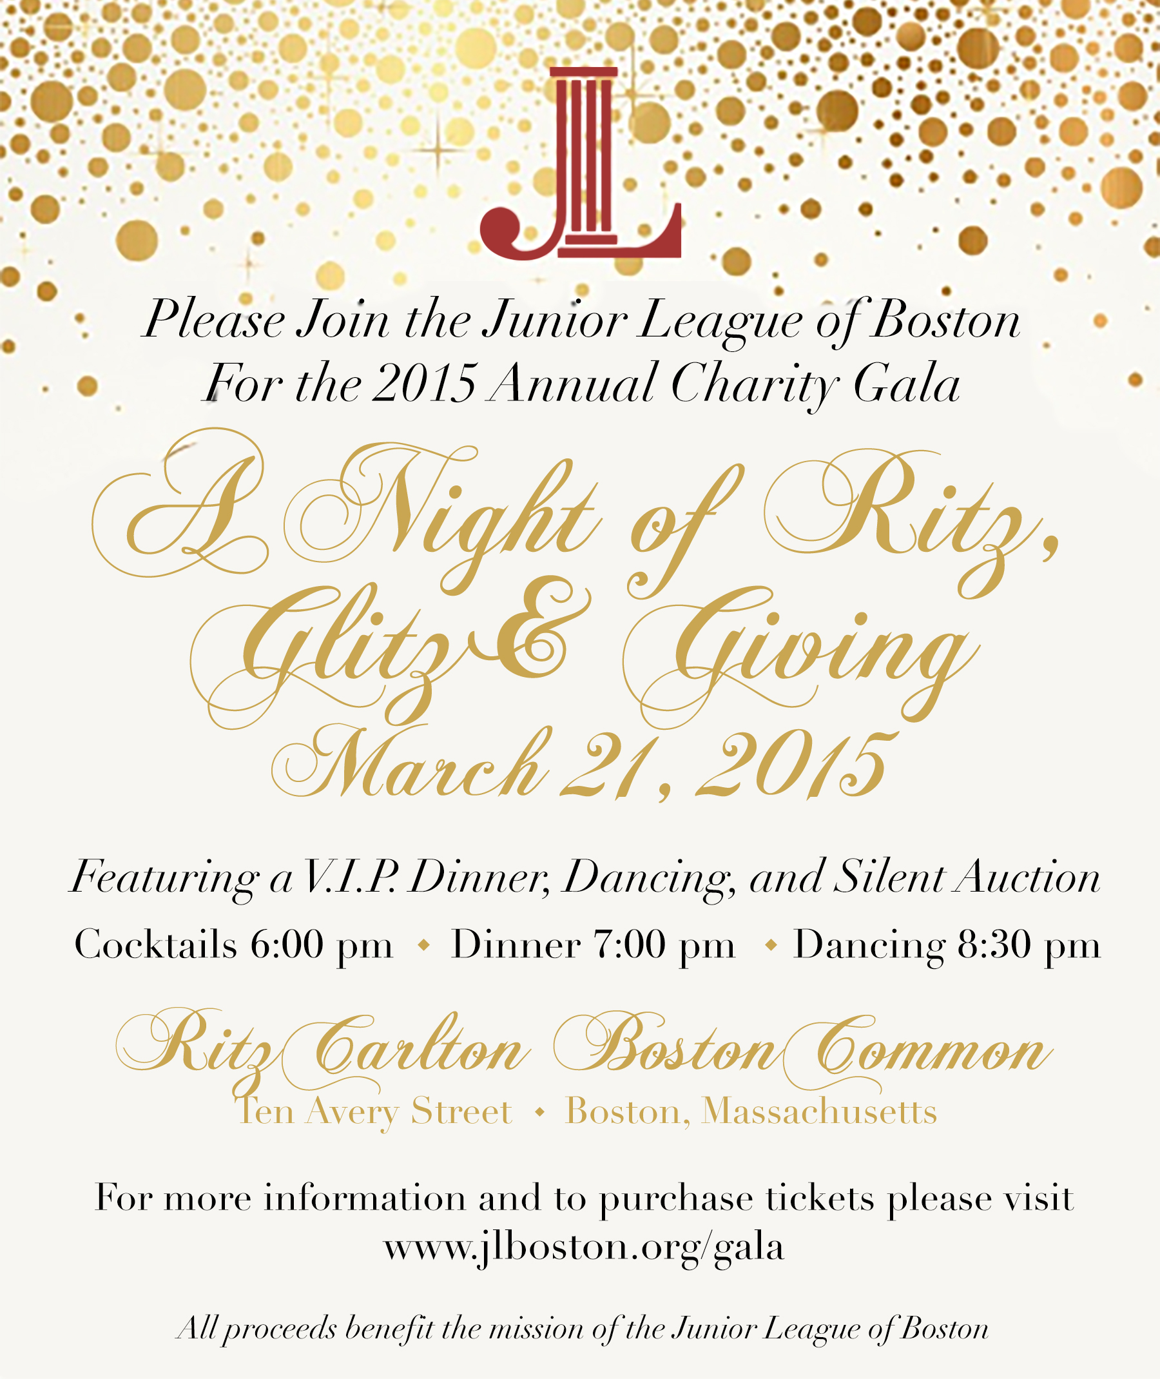

About the Junior League of Boston
The Junior League of Boston, Inc. is an all-women’s nonprofit organization focused on the wellness for girls: developing tomorrow's healthy confident women leaders. JL Boston is part of The Association of Junior Leagues International Inc. (AJLI), an organization of 292 Junior League chapters in four countries. AJLI is composed of more than 150,000 dedicated and creative women members from varying backgrounds and interests, who share a commitment to voluntarism within their communities. Founded in 1906, the Junior League of Boston originated as a progressive, motivated and dedicated collection of trained female volunteers. Today, its members proudly serve the greater Boston area through direct community service projects. Please go to www.jlboston.com for more information and to learn how you can support JL Boston.

